Title
Principal Author Name ⁽¹⁾, Co-Author Name ⁽²⁾, Co-Author Name ⁽³⁾…
⁽¹⁾ Affiliation, Complete mailing address (including country), Email:
^{(2)(3)…} Affiliation, Complete mailing address (including country), Email:

Keywords
e.g. launcher structures, micro-vibrations, high strain composites …

Abstract
Authors must deliver their full papers by the 27 February 2023 as electronic ‘PDF’ files to the dedicated website; details are given in Sections 10 and 11.
Note that the paper must be fully cleared for presentation at an open conference, as it will be part of the conference proceedings. The speaker is fully responsible for ensuring that technical data disclosed while in attendance is cleared for release through their sponsor and/or employer.

Please read the following instructions for the preparation of your paper in accordance with the conference proceedings. These instructions include proper formatting and submission instructions. Each submitted paper should resemble these instruction sheets in format and style. Start with a concise abstract (limited to 15 lines or 150 words) that summarizes the contents of the paper.

GENERAL SPECIFICATIONS
The paper must be prepared in this two-column format and should not be longer than 12 printed pages including figures, tables and references, and the size of the electronic version must not exceed 10MB of memory.

PAGE LAYOUT
Paper format:
- standard A4 (297x210 mm),
- two-column format (8 cm each column),
- margins: top 25 mm, left and right 20 mm, bottom 37 mm,
- fully justified.

Font:
- Text: Arial
- Variable: Arial italic
- Symbol: True Type Symbol font

Type Size:
- Paper title: 12 pt bold (TITLE)
- Author(s): 10 pt bold (Author)
- Affiliation(s): 10 pt italic (Affiliation)
- Normal text: 10 pt (regular text)
- Captions: 10 pt italic (Figure…)
- Text in tables: 9 pt
- Symbols: 10 pt (Ω ≅ φ )
- Sub/superscript: 7 pt (x ^{y})
- Page numbers: 10 pt (regular text)

HEADERS AND FOOTERS
Both the header and the footer should be left empty. Do not add page numbers.

TITLE AND AUTHOR AFFILIATION
The paper title, author(s) name(s), affiliation, complete mailing address and email should be centred at the top of the first page using the fonts and type sizes indicated above. If there are several authors, the complete affiliation should be given for each of them using superscripts ⁽¹⁾ in the authors ⁽²⁾ list to refer to them.

Headings
This sheet has been typeset in accordance with the style to be followed for the headings. Use the decimal system in Arabic figures for the numbering of headings and subheadings. Major (or section) headings are to be in capitals and bold.

Subheadings
Subheadings or subsection headings are to be in lower case with initial capitals and bold font. They should be flush with the left-hand margin, on a separate line.

Lower order subheadings
Lower order headings are to be in lower case with initial capitals and italic font. They should be flush with the left-hand margin, on a separate line.

EQUATIONS
Equations are to be numbered consecutively throughout the paper. Each equation number must be unique. Equations should be centred, with the equation number in parentheses flush with the right-hand margin of the column. Leave a blank line before and after equations. Always refer to equations by number, as Eq. 1 or Eqs. 3-6, not as ‘above’ or ‘below’.

$$T_{S}=\frac{T_{b}}{1+\left({λT_{b}}/α\right)\ln{ε}}$$ | (1)

FIGURES AND TABLES
Figures and tables can extend over two columns if required. Figure captions should be centred below the figures; table captions should be centred above the tables. Use full word ‘Figure 1’ or ‘Table 1’ in the caption. Use the abbreviation “Fig. 1” or “Tab. 1” in the text (even at the beginning of a sentence).

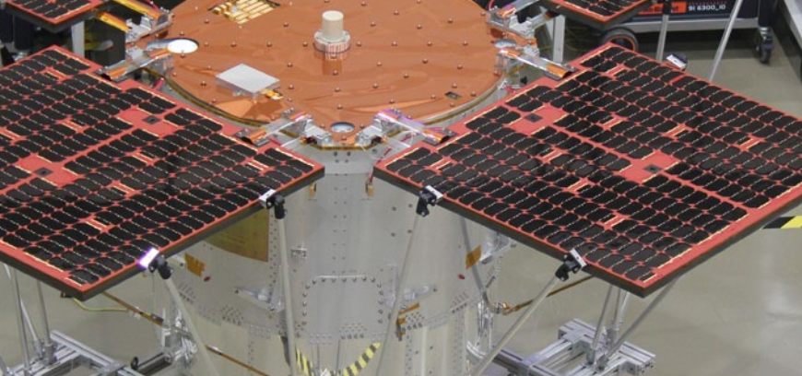
Figure 1: Figure caption

Table 1: Table caption
 | 2020 | 2021
January | 10 | 13
February | 11 | 14
March | 12 | 15

ABBREVIATIONS AND ACRONYMS
Define abbreviations and acronyms the first time they are used in the text, even after they have been defined in the abstract. Do not use abbreviations in the title unless they are unavoidable.

REFERENCES
Number citations consecutively in square brackets [1]. Refer simply to the reference number, as in [3]. Do not use ‘Ref. [3]’ or ‘reference [3]’ except at
the beginning of a sentence: ‘Reference [3] was the first …’. The title of the book or of the journal should be in italic script.

Sample References
1. Smith, J.M., Adams, B.A. & Wilson, A. (2002). The Future for Asteroid Exploration. Planet. Space Sci. 285(11), 123-126.
2. Johnson, A.B. & Radice, X.T. (2002). Comets for Beginners, Cambridge University Press, Cambridge, UK, pp103-106.
3. Svalgaard, L. & LeSager, P. (2003). What Heliosesimology Teaches us About the Sun. In Proc. 4th. ISCS ‘Solar Variability as an Input to the Earth’s Environment’ (Eds. H. Lacoste &
H. Xerxes), ESA SP-535 (CD-ROM), ESA Publications Division, European Space Agency, Noordwijk, The Netherlands.

PDF PREPARATION
In order to allow reasonable quality printing, please avoid excessive compression when making your PDF file. Generally, image resolutions should be
600 dpi for monochrome, 300 dpi for greyscale and colour.
VERY IMPORTANT: EMBED ALL FONTS and ensure that the PDF’s security setting is on
‘No Security’.

SUBMITTING THE PAPER
Papers must be delivered by 27 February 2023 at the latest, to be included in the proceedings.

Please upload your paper via the presenter tool on our website, using your email-address and your password.

Detailed information for presenters regarding upload of your paper, technical checks before the conference and briefing on the day of the presentation will be distributed in a dedicated e-mail.

If you need technical assistance while uploading your paper please contact:
contact@ecssmet2023.com

The proceedings will be downloadable at the end of the conference on your personal account.

Further information
For further information …
- about preparing your paper, please contact: contact@ecssmet2023.com
- about the Conference, please visit: https://ecssmet2023.com/

